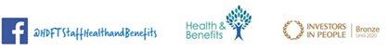

The Majestic Hotel has kindly offered a discount for our staff at the majestic hotel for a spa treatment.

The web page is https://theharrogatespa.com/special-offers/

To book staff will need to email relax@theharrogatespa.com and quote HHCC as the code – info is below but the package is discounted from £89 to £69.

Please note that this offer is in place from the 12th April 2021 to 17th May 2021.

We hope staff get the opportunity to enjoy this offer.

